
April Employee Spotlight
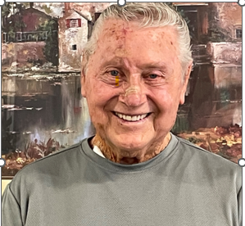

Meet Wayne Latka, School Crossing Guard Clerk. A much-valued employee for the SRDA School Crossing Guard program since 1992! Wayne’s duties are to ensure that all of the crossing guards are at their assigned locations all around the City of Pueblo, to find a replacement guard if they are out sick and to ensure the timesheets are completed and turned in on time. Wayne first applied to be a crossing guard and really enjoyed being around the kids and ensuring that they can cross the street safely on their way to school, as we all know that sometimes kids do not pay attention when crossing in traffic. It is a blessing to have conscientious employees standing by to make it safe. At the same time that he was a crossing guard, Wayne also delivered Meals on Wheels bringing lunch to our homebound community members.
Mr. Latka previously worked for 22 years in the Maximum-Security unit at the Colorado Mental Health Institute, a job that he truly enjoyed until an injury prevented him from returning. As a kid, he played baseball at Central High School and then semi-pro ball. He was also a coach for women’s softball, semi-pro baseball, and Bantam league football. In 1952, Wayne won an all-expenses trip to NYC to see the World Series because he was the most promising player (pitcher) in Pueblo.
Wayne and his wife, Candace, enjoy their time together with a blended family that includes 7 kids and 8 grandchildren and the dog. He likes to work in the yard, enjoys housework and likes to fish, hunt and camp. Together they enjoy travelling to historic sites to learn more about our beautiful state and country.
Thank you, Wayne! We are grateful to have such a dedicated, hard-working team member to help ensure the safety of our local school kids and our team of crossing guards.
We are accepting volunteer drivers to deliver meals to homebound older adults. Through meal delivery, our drivers serve as a friendly face to our often socially isolated homebound clients. All drivers are background checked and reimbursed for mileage costs.
To find out more about our nutrition programs, contact 719-543-0100 to inquire.

